St. Joseph’s RC Voluntary Academy

Online Safety Policy and Acceptable Use of ICT Agreements

Last reviewed March 2025

Our Mission Statement
We come together as Saint Joseph’s family to
learn, share our faith and do our best
to follow in the footsteps of Jesus.

As a Catholic community we come together to celebrate our love of God and each other, by following Jesus’ example of love, forgiveness and truth.

- We provide a safe and happy school recognising the achievements, talents and personal worth of every child.

- We nurture our children in the spirit of peace and reconciliation, encouraging the values of love, care and respect within all our relationships.

- We encourage our children to be responsible by caring for the world that God created and by being aware of those in need in the wider community.

1. Introduction

We understand the responsibility we have to educate our pupils on online safety issues; teaching the children appropriate behaviours and critical thinking skills to enable them to remain both safe and legal when using the internet and related technologies, in and beyond the context of the classroom.

We have a whole school approach to the safe use of ICT and creating this safe learning environment includes three main elements:

- an effective range of technological tools
- policies and procedures, with clear roles and responsibilities
- a comprehensive online safety programme for pupils, staff and parents.

Purpose and Scope: Online safety is an integral part of safeguarding and requires a whole school, cross-curricular approach and collaboration between key school leads. It complements existing and forthcoming subjects including Health, Relationships and Sex Education, Citizenship and Computing; it is designed to sit alongside our school’s statutory Safeguarding Policy. This policy outlines the standards and procedures for safe online conduct and usage within our school. It applies to all members of St Joseph’s RC Academy including: all students, staff, volunteers, parents/carers, and visitors engaging with school’s digital platforms and technologies.

Rational: Engaging with digital technologies is an integral part of our learning in our school; however, this comes with potential risks. This policy establishes guidelines to ensure a safe online environment and promote responsible digital citizenship. Accordingly, this policy is written in line with the relevant legislation and guidance listed below.

Legal Framework:
- The Children Act 1989 and 2004
- The Education Act 2002
- The Protection of Freedoms Act 2012
- Keeping Children Safe in Education (KCSIE) 2024
- Working Together to Safeguard Children
- Prevent Duty Guidance

2. Roles and Responsibilities

Online safety is recognised as an essential aspect of strategic leadership in St-Joseph’s RC Academy. ICT Subject Leader has received CEOP (Child Exploitation and Online Protection) training.
Carole Carlile (Headteacher) has overall responsibility. Jack Carr (Deputy Headteacher) Rowena Green (Family liaison) and Jon Sutcliffe (ICT / Online Safety Co-ordinator) are named staff for children and staff to report any concerns to, in regard to online safety.

It is the role of these staff members to keep abreast of current issues and guidance through organisations such as Calderdale LA, Becta, CEOP (Child Exploitation and Online Protection), and Child Net. The Headteacher ensures Senior Management and Governors are updated as necessary. All teachers are responsible for promoting and supporting safe behaviours in their classrooms and follow school online safety procedures.

All staff should be familiar with the school’s policy including:

- safe use of e-mail
- safe use of the Internet
- safe use of the school network, equipment and data
- safe use of digital images and digital technologies, such as mobile phones and digital cameras
- publication of pupil information/photographs on the school website
- procedures in the event of misuse of technology by any member of the school community (see appendices)
- the school community’s role in providing online safety education for pupils.

Staff are reminded/updated about online safety regularly and new staff receive information on the school’s acceptable use policy as part of their induction. Supply Teachers must sign an acceptable use of ICT agreement before using technology equipment in school (see appendix 1 for staff acceptable use agreement).

Managing the school online safety messages

We endeavour to embed online safety messages across the curriculum whenever the internet and/or related technologies are used. The online safety policy will be shared with new staff, including the acceptable use policy as part of their induction. Online safety posters will be prominently displayed on ICT display boards.

Infrastructure and Filtering and Monitoring
This school:
- Has the educational filtered secured broadband connectivity;
- Uses SURFPROTECT filtering and monitoring system which blocks and restricts pupils from inappropriate content that may fall into categories such as pornography, race hatred, gaming, sites of an illegal nature, etc. This is provided by our local education authority;
- Daily reporting is enabled through this system and the features sends reports to the Computing Lead’s email address. These reports are the UK prevent report and the suspicious search query report.
- Monitoring is vigilant during lessons by the class teachers and all juniors have an individual log in so school can identify users.
- Ensures a healthy network through the use of anti-virus software and network set-up so staff and pupils cannot download executable files;
- Uses DfE, LA secured email to send personal data over the internet and uses encrypted devices or secure remote access were staff need to access personal level data off-site;
- Blocks all chat rooms and social networking sites except those that are part of an educational network or approved Learning Platform;
- Uses security time-outs on Internet access -practical / useful

3. Curriculum Computing and online resources

Curriculum Computing and online resources are increasingly used across the curriculum. We believe it is essential for online safety guidance to be given to the pupils on a regular and meaningful basis. We continually look for new ways to promote online safety.
• We provide opportunities within a range of curriculum areas to teach about online safety.
• Educating pupils on the dangers of technologies that may be encountered outside school is done informally, when opportunities arise and as part of the curriculum.
• Pupils are taught about copyright and respecting other people’s information, images, etc through discussion, modelling, and activities as part of the ICT curriculum.
• Pupils are aware of the impact of online bullying through PSHE and know how to seek help if they are affected by these issues. Pupils are also aware of where to seek advice or help if they experience problems when using the Internet and related technologies.
• Pupils are taught to critically evaluate materials and learn good searching skills through cross curricular teacher models, discussions and via the ICT curriculum.

4. Managing Internet Access

The internet is an open communication medium, available to all, at all times. Anyone can view information, send messages, discuss ideas and publish material which makes it both an invaluable resource for education as well as a potential risk to young people.
Students will have supervised access to Internet resources through the school's fixed and mobile internet technology.
Staff will preview any recommended sites before use. If Internet research is set for homework, specific sites will be suggested that have previously been checked by the teacher. It is advised that parents recheck these sites and supervise any further research.
Our internet access is controlled through the SURFPROTECT filtering service. Staff and pupils are aware that school-based email and internet activity can be monitored and explored further if required.
If staff or pupils discover an unsuitable site, the screen must be switched off/closed and the incident reported immediately to the online safety co-ordinator and immediate contact made with the network manager, so that they can block the site.
It is the responsibility of the school, by delegation to the network manager, to ensure that anti-virus protection is installed and kept up-to-date on all school machines. Any changes to filtering must be authorised by the headteacher.

5. Security and Data Protection

The school and all staff members comply with the Data Protection Act 1998.
Personal data will be recorded, processed, transferred and made available according to the act. Password security is essential for staff, particularly as they are able to access and use pupil data. Staff have secure passwords which are not shared with anyone. All users read and sign an Acceptable Use Agreement to demonstrate that they have understood the school's Online safety Policy.

6. Online safety Complaints/Incidents

As a school we always take all precautions to ensure online safety. However, due to the international scale and linked nature of internet content, the availability of mobile technologies and the speed of change, it may mean that unsuitable material may briefly appear on a computer or mobile device. The school cannot accept liability for material accessed or any consequences of this. Complaints should be made to the Headteacher. Incidents should be logged and the flowchart for managing an online safety incident is to be followed.

It is important that the school work in partnership with pupils and parents to educate them about Cyber bullying and children; staff and families need to know what to do if they or anyone they know are a victim of Cyber bullying. All bullying incidents should be recorded and investigated via the incident log form (Appendix 6).

7. Review of Policy

There are on-going opportunities for staff, children and families to discuss online safety concerns with our Headteacher, Deputy Headteacher, Computing co-ordinator and School Family liaison. Consideration will be given to the implications for future whole school development planning. The policy will be amended if new technologies are adopted or any guidance or orders are updated.

This policy was agreed by the Governors in the Spring term 2025 and is reviewed annually.

Appendices
1. Primary Pupil Acceptable Use of ICT Agreement/Online safety Rules
2. Parent Internet use form/letter
3. Staff, Governor and Visitor Acceptable Use Agreement
4. Flow chart for managing an online safety incident not involving any illegal activity
5. Flow chart for managing an online safety incident involving illegal activity
6. Online safety Incident Log
7. Advice for children on Cyber bullying
8. Advice for parents on Cyber bullying
9. KS1 Internet tips
10. KS2 Internet tips
11. Online safety questionnaires

Appendix 1

Primary Pupil Acceptable Use of ICT Agreement / Online safety Rules

I will only use ICT in school for school purposes.
I will not tell other people my ICT passwords.
I will only open/delete my own files.
I will not bring software, CDs or ICT equipment into school without permission.
I will only use the Internet after being given permission from a teacher.
I will make sure that all ICT contact with other children and adults is responsible, polite and sensible.
I will not deliberately look for, save or send anything that could be upsetting or not allowed at school. If I accidentally find anything like this, I will close the screen and tell a teacher immediately.
I will not give out my own details such as my name, phone number or home address.
I will not use technology in school time to arrange to meet someone unless this is part of a school project approved by a teacher and a responsible adult comes with me.
I will be responsible for my behaviour when using ICT because I know that these rules are to keep me safe.
I know that the school may check my use of ICT and monitor the Internet sites I have visited, and that my parent/carer will be contacted if a member of school staff is concerned about my Online safety.

Name /Signature .................................................................................

Class ....................................................................................................

Date ...................................................................................................

Appendix 2

ST JOSEPH’S RC VOLUNTARY ACADEMY
Wellington Road, Todmorden, OL14 5HP
Tel: 01706812948
Email: admin@stjosephs.romerocat.com
Website: www.st-josephs-tod.org.uk
Headteacher: Mrs C Carlile

Date:
Dear Parents/Carers,
Computing, including the internet, e-mail and mobile technologies, has become an important part of learning in schools. We expect all children to be safe and responsible when using any aspects of Computing.
Please read and discuss with your child the Online safety rules overleaf and return this sheet signed by both you and your child. If you have any concerns or would like some explanation, please contact your child’s class teacher.

This Acceptable Use of ICT Agreement is a summary of our Online safety Policy which is available in full on our website or as a hard copy in our Office/Reception.
Yours sincerely,
Mrs C Carlile
Headteacher

Pupil:
I have read, understood and agreed with the Rules for Acceptable use of ICT.

Signed ……………………………………………. (child where appropriate)

Parent's/Carer’s Consent for Internet Access

I have read and understood the school rules for Acceptable Use of ICT and give permission for my son / daughter to access the Internet in school. I understand that the school will take all reasonable precautions to ensure pupils cannot access inappropriate materials. I understand that the school cannot be held responsible for the nature or content of materials accessed through the Internet.
I agree that should my son/daughter need to access the internet, in regard to school, at home or anywhere else, that I will take all reasonable precautions to ensure he/she cannot access inappropriate materials and that he/she will use the computer in an appropriate manner.

Signed………………………...……………… (parent/carer)

Date………………………….

Appendix 3

St-Joseph’s RC Voluntary Academy Acceptable Use of ICT Agreement Staff, Governor and Visitor Acceptable Use Agreement / Code of Conduct

Computing and the related technologies such as email, the internet and mobile devices are an expected part of our daily working life in school. This policy is designed to ensure that all staff are aware of their professional responsibilities when using any form of ICT. All staff are expected to sign this policy and adhere at all times to its contents. Any concerns or clarification should be discussed with Carole Carlile, (Headteacher), or Jon Sutcliffe, Computing Co-ordinator.

I will only use the school’s email / Internet / Intranet and any related technologies for professional purposes or for uses deemed ‘reasonable’ by the Head or Governing Body.
I will comply with the Computing system security and not disclose any passwords provided to me by the school or other related authorities.
I will ensure that all electronic communications with pupils and staff are compatible with my professional role.
I will not give out my own personal details, such as mobile phone number and personal email address, to pupils.
I will only use the approved, secure email system(s) for any school business.
I will ensure that personal data is kept secure and is used appropriately, whether in school, taken off the school premises or accessed remotely. Personal data can only be taken out of school or accessed remotely when authorised by the Head or Governing Body.
I will not use or install any hardware (including USB sticks) or software without permission from the online safety co-ordinators.
I will not browse, download, upload or distribute any material that could be considered offensive, illegal or discriminatory.
Images of pupils and/ or staff will only be taken, stored and used for professional purposes in line with school policy and with written consent of the parent, carer or staff member. Images will not be distributed outside the school network without the permission of the parent/ carer, member of staff or Head teacher.
I understand that all my use of the Internet and other related technologies can be monitored and logged and can be made available, on request by the Headteacher.
I will respect copyright and intellectual property rights.
I will ensure that my online activity, both in school and outside school, will not bring my professional role into disrepute.
I will support and promote the school’s online safety policy and help pupils to be safe and responsible in their use of ICT and related technologies.
I will ensure that only children whose parents have given permission for them to use the Internet and ICT are enabled to do so at school.

User Signature

I agree to follow this code of conduct and to support the safe use of ICT throughout the school.

Signature …….………………….………… Date ……………………
Full Name …………………………………......................................... (printed)
Job title: ………………………………………………………………….

Appendix 4

No
Yes
No
Does the incident involve a member of staff?
Yes
Was the child the victim or instigator?
Pupil as victim

Review incident and identify if other pupils were involved.
Decide appropriate sanctions based on school rules.
Inform parents/carers if serious or persistent incident.
In serious incident contact the relevant agency as the child as instigator could be at risk.
Review school procedure/policy to develop best practice.

Pupil as instigator

In-school action to support pupil by
one or more of the following:
Class teacher
Headteacher
Designated person for Child Protection.
Inform parents/carer as appropriate
If the child is at risk contact the relevant outside agency.

If the member of staff has:
- behaved in a way that has or may have harmed a child.
- possibly committed a criminal offence
- behaved in a way which indicates s/he is unsuitable to work with children.
Headteacher would be notified and appropriate action would be taken after:
- review evidence and determine whether incident is accidental or deliberate
- decide upon the appropriate course of action follow school disciplinary procedures.
The online safety co-ordinator and/or Headteacher should:
record in the online safety incident log keep any evidence if the member of staff has:
- behaved in a way that has or may have harmed a child.
- possibly committed a criminal offence
- behaved in a way which indicates s/he is unsuitable to work with children.

Appendix 5

1. Inform the police and follow any
advice given by the police otherwise:
2. Confiscate any laptop or other device and if related to school
network disable user account
3. Save ALL evidence but DO NOT
view or copy. Let the police review
the evidence.

If a pupil is involved contact the Child Protection School Liaison Officer.
If a member of staff is involved contact the relevant outside agency
No
If the incident did not involve any
illegal activity, refer to the flowchart
relating to non-illegal incidents – Appendix 4.
Yes
Was illegal material or activity found of suspected?
Flowchart for Managing an online safety incident involving illegal activity
Following an incident, the online safety co-ordinator and/or Headteacher will need to decide quickly if the incident involves any illegal activity

Appendix 6

St-Joseph’s RC Voluntary Academy Online safety Incident Log

Details of ALL online safety incidents to be recorded in the Incident Log by the online safety co-ordinator. This incident log will be monitored termly by the online safety coordinator and Head teacher.

Date & time | Name of pupil or staff member | Male or Female | Room and computer/device number | Details of incident (including evidence) | Actions and  reasons

Appendix 7

Advice for Children on Cyber-bullying

If you're being bullied by phone or the Internet:

Remember, bullying is never your fault.
It can be stopped, and it can usually be traced.
Don't ignore the bullying.
Tell someone you trust, such as a teacher or parent, or call an advice line.
Try to keep calm.
If you are frightened, try to show it as little as possible.
Don't get angry, it will only make the person bullying you more likely to continue.
Don't give out your personal details online - if you're in a chatroom, watch what you say about where you live, the school you go to, your email address etc.
All these things can help someone who wants to harm you build up a picture about you.
Keep and save any bullying emails, text messages or images. Then you can show them to a parent or teacher as evidence.
If you can, make a note of the time and date bullying messages or images were sent, and note any details about the sender.
There's plenty of online advice on how to react to cyberbullying.
For example, www.kidscape.org and www.wiredsafety.org have some useful tips.

Text/video messaging

You can easily stop receiving text messages for a while by turning off incoming messages for a couple of days. This might stop the person texting you by making them believe you've changed your phone number.
To find out how to do this, visit www.wiredsafety.org.
If the bullying persists, you can change your phone number. Ask your mobile service provider.
Don't reply to abusive or worrying text or video messages. Your mobile service provider will have a number for you to ring or text to report phone bullying. Visit their website for details.
Don't delete messages from cyberbullies. You don't have to read them, but you should keep them as evidence.
Text harassment is a crime. If the calls are simply annoying, tell a teacher, parent or carer. If they are threatening or malicious and they persist, report them to the police, taking with you all the messages you've received.

Phone calls

If you get an abusive or silent phone call, don't hang up immediately. Instead, put the phone down and walk away for a few minutes. Then hang up or turn your phone off. Once they realise they can't get you rattled, callers usually get bored and stop bothering you.
Don't give out personal details such as your phone number to just anyone. And never leave your phone lying around. When you answer your phone, just say 'hello', not your name. If they ask you to confirm your phone number, ask what number they want and then tell them if they've got the right number or not. You can use your voicemail to vet your calls. A lot of mobiles display the caller's number. See if you recognise it. If you don't, let it divert to voicemail instead of answering it.
Do not leave your name on your voicemail greeting. You could get an adult to record your greeting. Their voice might stop the caller ringing again. Almost all calls nowadays can be traced.
If the problem continues, think about changing your phone number. If you receive calls that scare or trouble you, make a note of the times and dates and report them to the police. If your mobile can record calls, take the recording too.

Emails

Never reply to unpleasant or unwanted emails — the sender wants a response, so don't give them that satisfaction.
Keep the emails as evidence. And tell an adult about them. Ask an adult to contact the sender's Internet Service Provider (ISP) by writing abuse@ and then the host, e.g. abuse@hotmail.com
Never reply to someone you don't know, even if there's an option to 'unsubscribe'. Replying simply confirms your email address as a real one.

Web bullying

If the bullying is on a website (e.g. Bebo) tell a teacher or parent, just as you would if the bullying was face-to-face – even if you don’t actually know the bully’s identity.
Serious bullying should be reported to the police - for example threats of a physical or sexual nature. Your parent or teacher will help you do this.

Chat rooms and instant messaging

Never give out your name, address, phone number, school name or password online.
It's a good idea to use a nickname and don't give out photos of yourself.
Don't accept emails or open files from people you don't know. Remember it might not just be people your own age in a chatroom.
Stick to public areas in chat rooms and get out if you feel uncomfortable. Tell your parents or carers if you feel uncomfortable or worried about anything that happens in a chat room.
Think carefully about what you write; don't leave yourself open to bullying.
Don't ever give out passwords to your mobile or email account.

Three steps to stay out of harm’s way:

1. Respect other people - online and off. Don’t spread rumours about people or share their secrets, including their phone numbers and passwords.
2. If someone insults you online or by phone, stay calm – and ignore them.
3. Think how you would feel if you were bullied. You’re responsible for your own behaviour – make sure you don’t distress other people or cause them to be bullied by someone else.

Appendix 8
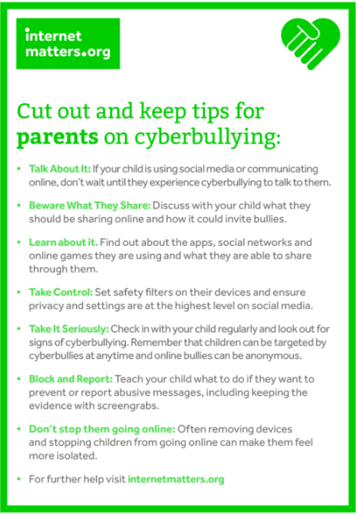

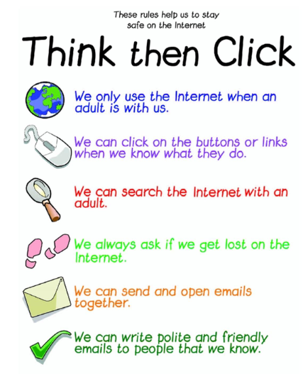
Appendix 9

Appendix 10
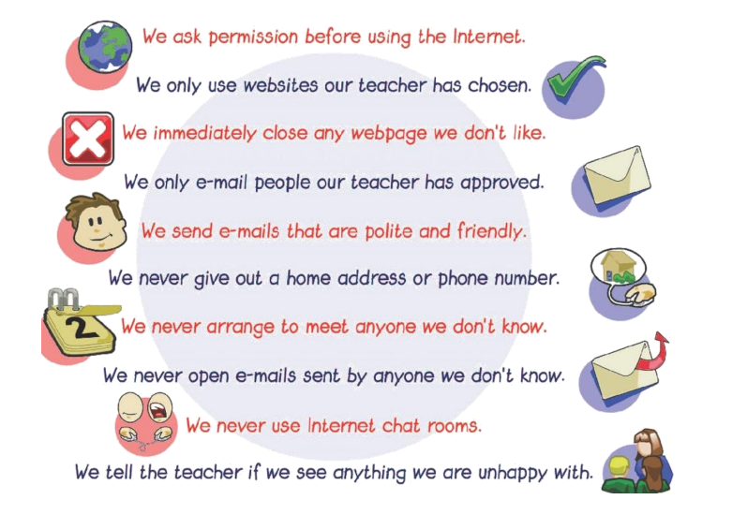

Appendix 11

Anti-Bullying & Cyber bullying questionnaire KS1

Class…………

No. of pupils taking part …………

1. Does the word bullying mean;

Someone is unkind to you once……………………………………………

Someone is unkind to you more than once………………………….

2. If you were unhappy at school, who would you tell?
…………………………………………………………………………………………………………………

How many said they did not know who to tell?.........................................

3. How many children use the internet at home?
.…………………………………………

5. How many of those children use the internet;

(a) Alone…………….
(b) With an adult…………………

6. If you were out with your family and you got separated from them, what would you do?
…………………………………………………………………………………………………………………………
…………………………………………………………………………………………………………………………

(Please explain the importance of knowing either their address, post code or a contact number)

Anti-Bullying & Cyber bullying KS2 Questionnaire

Name __________________________ Date _________________ Class __________________

1. What does the word bullying mean to you?
________________________________________________________________________________

2. What do the words Cyber bullying mean?
________________________________________________________________________________

3. If you felt that you were being bullied in our school, what would you do?
________________________________________________________________________________

4. If you felt that you were being bullied outside of school, what would you do?
________________________________________________________________________________

5. If you play games on the internet, do you play with people you do not know personally?
________________________________________________________________________________

9. Do you know how to report rude or bullying messages on line?
________________________________________________________________________________

10. Write either your home address or a telephone number you could call in an emergency.
________________________________________________________________________________

