ST. JOSEPH’S RC ACADEMY
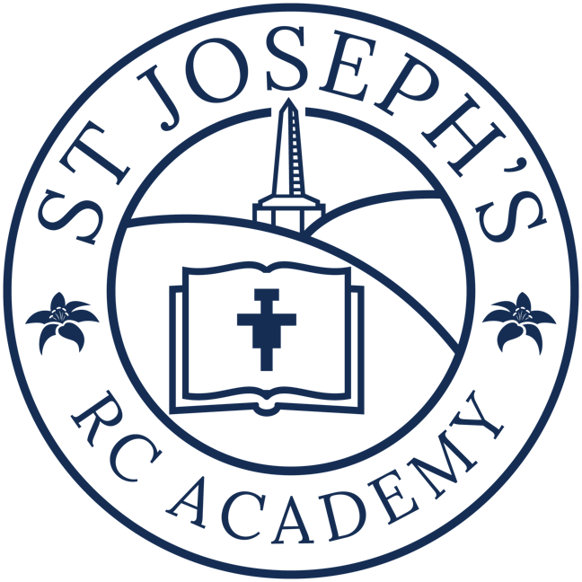
UNIFORM POLICY

Policy Approved: March 2025
Due for Review: March 2026

School Uniform
At St. Joseph's we believe that school uniform is important; not only does it contribute to our sense of belonging together as a school family, it also means we look smart and instils a sense of pride in our school. We ask that all children wear our uniform.
Our uniform consists of:

Nursery:
Grey or black trousers or skirt
White top
School Jumper

Uniform A:
A Navy v-neck jumper to include the school logo
A white shirt and school tie (tie is optional for EYFS Children)
Grey trousers or grey shorts with dark grey or black socks
Black School Shoes

PE Kits:
Navy Shorts (available with logo option)
Plain white T’ Shirt (available with logo option)
Optional: Navy Hoodie with school logo
Children should work in bare feet for gymnastics and dance in the Hall.
Trainers for outside

Uniform B:
A Navy v-neck jumper or cardigan to include the school logo
A white shirt and school tie
A grey skirt or pinafore with white, grey or navy socks or plain navy tights
Or in the Summer Term - a navy and white summer dress ( with white, grey or navy socks)
Black School Shoes
Navy, white or grey hair bobbles, ribbons and clips.
Optional - Plain black or navy one piece Hijab
PE Kits:
Navy Shorts (available with logo) or navy leggings (available with logo)
Plain white T’ Shirt (available with logo)
Optional: Navy Hoodie with school logo
Children should work in bare feet for gymnastics and dance in the Hall.
Trainers for outside

Each child should also come to school in a warm, waterproof coat.
Only one pair of stud earrings can be worn and no other jewellery should be worn.
No make-up or nail varnish should be worn.
Hair accessories should be only those stated with Uniform B and hair should be a natural colour, not dyed. Short hair should be cut not shaved and should not have 'tram lines' or patterns.
Parents are asked to ensure that all items of clothing are clearly labelled with their child's name. Lost items will be placed in the lost property box located at the back of the hall.

