St. Joseph’s RC Voluntary Academy
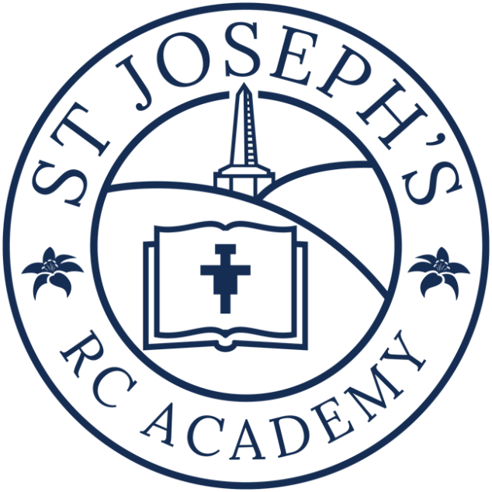
Accessibility Plan

Table of Contents

School mission statement 3

Introduction 4

The planning duties of the DDA 4

Disability 5

Primary accessibility plan 6

Improving Access to the Physical Environment 8

Improving Access to information about the Curriculum 9

SCHOOL MISSION STATEMENT

We come together as Saint Joseph's family to
learn, share our faith and do our best
to follow in the footsteps of Jesus.

5Ws

Welcome Word Welfare Worship Witness
At Saint Joseph's we are happy to welcome each child as loved by God.
We listen to God's word and share the Good News about Jesus.
Our relationships are based on the belief that everyone is special, and we can all be kind and loving.
We make a space in our hearts for forgiveness.
Together, we place prayer and worship at the heart of our school day.
As a school, we tell God's message of hope.
We promise to live as a caring, sharing and loving school family.

Introduction

The Disability Discrimination Act 1995 was extended to include education by the SEN and Disability Act 2001 (SENDA). The board of Governors of St Joseph’s RC Primary School recognises the following duties that this and the Equality Act 2010 places upon them:
- Not to treat disabled pupils less favourably for a reason related to their disability
- To make reasonable adjustments for disabled pupils, so that they are not at a substantial disadvantage
- To plan to make reasonable adjustments to the school buildings, so that there is an increased access to education for disabled pupils and to make the school buildings more accessible for disabled parents.
The planning duties of the DDA makes three requirements of the Governing body

- To increase the extent to which disabled pupils can participate in the school curriculum. This requirement is intended to improve access to a full broad and balanced curriculum and could include documents such as staffing, timetabling and training.

- To improve the environment of the school to increase the extent to which disabled pupils can take advantage of education and associated services.

This requirement covers improving the physical environment of the school and obtaining physical aids to access education. The physical environment includes things such as steps, stairway, kerbs, exterior surfaces and paving, parking areas, building entrances and exits (including emergency escape routes), internal and external doors, gates, toilets and washing facilities, lighting ventilation, lifts, floor coverings, signs and furniture.

Aids to physical access include ramps, handrails, lifts, widened doorways, electromagnetic doors, adapted toilets and washing facilities, adjustable lighting, blinds, induction loops and way-finding systems.

Physical aids to access education also cover things such as ICT equipment, enlarged computer screens and keyboards, concept keyboards, switches, specialist desks and chairs and portable aids for children with motor coordination and poor hand/eye skills, such as extra robust scientific glassware and specialist pens and pencils.

- Improving the delivery to disabled pupils of information, which is provided for pupils who are not disabled in a format appropriate to their needs.

This part of the duty covers information normally provided by the school in writing to its pupils – such as handouts, timetables, textbooks, information about school events – available to disabled pupils.

This will include alternative formats such as Braille, audio tape and large print and also the provision of information orally, through lip speaking or sign language, or through a recognised symbol system or ICT. This information should also be made available within a reasonable time frame and take account of the pupils’ disabilities and pupils’ and parents’ preferred formats.

We are required to resource, implement and review our accessibility plan as necessary. This plan will be monitored and evaluated by the governing body through the curriculum committee.

Disability

‘A person has a disability if he or she has a physical or mental impairment that has a substantial long-term adverse effect on his or her ability to carry out day to day activities’ – the DDA definition of disability.

St Joseph’s policy on equality is to ensure that there is no discrimination against any sub-group within its community, be it because gender, ethnicity, culture, religion, language, sexual orientation, age, ability, disability and social circumstances. With this in mind, the school has put in place policies and procedures so that disabled people are not treated less favourably in the service, education or support they receive than people without a disability. Meeting these requirements is consistently evaluated.

St JOSEPH’S PRIMARY PLAN FOR ACCESSIBILITY 2023 - 2024
- Improving Access to Curriculum

Target | Actions | Timescale/Cost | Responsibility | Outcomes
Improve access for all identified SEN children to curriculum | Ensure all staff are aware of resources and software available | Ongoing | SENCO  ICT Leader  Subject Leaders | More efficient use of existing resources.
Ensure all staff have access to specific training on disability / inclusive issues | Use staff training audit to identify need.  Include this aspect of training in teachers/ TAs Performance Management. | Ongoing | Head/SENCO | Appropriately trained staff with awareness of disability / inclusion issues.
Ensure all staff have access to specific training on medical conditions. | Identify specific training needs and plan/deliver training. | Ongoing | Head/SENCO | Appropriately trained staff with awareness of medical conditions issues.
Monitor inclusive nature of school trips. | Consideration made in risk assessments for any pupils with identified disability issues. | On-going | Deputy Head/SENCO | Evidence of consideration of any particular need, ensuring full inclusive practice.
Review PE curriculum to ensure access for all pupils | Identify pupils with particular needs and difficulties relating to physical activity.  Review PE coverage, equipment and differentiation possible.  Ensure differentiation in planning for identified needs. | Annually, Autumn | PE Co-ordinator / Teaching Staff | Good differentiation evident in PE sessions.  Monitoring indicates high level of involvement by all pupils
Training and information for staff in the identification of and teaching children with SEND. | All staff attend training opportunities and read provided literature. Outreach provision from external agencies. | On-going using outreach providers and cluster meetings | SENCO | Children with SEND are successfully included in all aspects of school life.
All extracurricular activities are planned to ensure they are accessible to all children | Review all out-of-school provision to ensure compliance with legislation | Annually, Summer | SLT | All out-of-school activities will be conducted in an inclusive environment with providers that comply with all current and future legislative requirements
Classrooms are optimally organised to promote the participation and independence of all pupils. | Teachers assess layout of furniture and equipment to support the learning process in individual class bases.  Use of visual timetables across the school.  Develop visual resources. | On-going, Autumn | SENCO  Teachers | Lessons start on time without the need to make adjustments to accommodate the needs of individual pupils. Children have ready access to a range of resources to support their learning.
Training for awareness raising of disability Issues | Provide training as required for governors, staff, pupils and parents.  Discuss perception of issues with staff to determine the status of school by sharing the plan annually. | On-going | SENCO  Headteacher | Whole school community aware of issues relating to Accessibility
Ensure all children on SEND list have provision identified. | Children included within provision map. | On-going, termly | SENCO | Provision map is up to date and forms a key part of the planning process for all pupils

- Improving Access to the Physical Environment

Target | Actions | Timescale/Cost | Responsibility | Outcomes
School has raised awareness of the access needs of all its pupils | Access needs taken into consideration on all IEPs. | Ongoing | Teaching staff & SENCO | All pupils able to access areas
All building work to take into account DDA compliance and good practice | All proposed building work to be assessed for DDA issues such as door width. | Ongoing | School Business Manager  Site Manager | New building work should improve access for all
Improve signage for visitors | Ensure the site is considered from the viewpoint of the visually impaired and appropriate signage put in place. | Ongoing | School Business Manager  Site Manager | Welcoming and accessible entrance to school
Ensure fire escape routes are accessible to all | All new fire escape routes to be DDA compliant.  Individual Personal Emergency Evacuation Plan put in place if required. | Ongoing | SLT  SENCO | Safe evacuation of all children in the event of fire.

- Improving Access to information about the Curriculum

Target | Actions | Timescale/Cost | Responsibility | Outcomes
To review information to parents/carers to ensure it is accessible | Ask parents about access needs when child is admitted to school  Produce newsletter in alternative format, if required | Ongoing  If required | School Business Manager | All parents have access to school information

.

